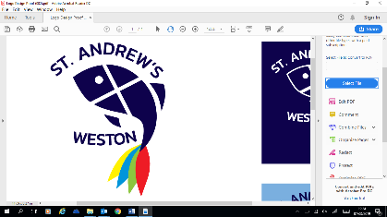

St Andrew’s Church of England Primary School 2023 - 2024
Governor Attendance to Local Academy Committee Meetings

 |  | St Andrew’s LAC Meeting | St Andrew’s LAC Meeting | St Andrew’s LAC Meeting | St Andrew’s LAC Meeting | St Andrew’s LAC Meeting | St Andrew’s LAC Meeting
Governor | Role | 28/09/2023 | 30/11/2023 | 25/01/2024 | 14/03/2023 | 16/05/2024 | 20/06/2024
Hollie Barnacle | Staff Governor | Y | Y | Y | Y | Y | Y
Jan Griffiths | Co-opted Governor | Y | Y | Y | Y | Y | Y
Paul Hayward | Headteacher | Y | Y | Y | Y | Y | Y
Jon Heathcote | Parent Governor | Y | N | NS | N | Y | NS
Matthew Keates | Parent Governor | Y | Y | Y | Y | Y | Y
James Kolanko | Co-opted Governor | Y | Y | Y | Y | N | Y
Rev. Viv Starkie | Foundation Governor | N | Y | NS | Y | Y | N
Graham Tague | Co-Opted Governor | Y | Y | Y | NS | Y | Y
Vacancy | Foundation Governor | - | - | - | - | - | -

Y = Attended
N = Apologies Accepted
NA = Apologies Not Accepted
NS = No Apologies Sent
- = Not Applicable

